Configure replication for Azure VMs in Azure Site Recovery - Azure Site Recovery | Microsoft Learn
🌐 Azure Site Recovery: Master Disaster Recovery & Business Continuity! 🚀🔐 | In Tamil
DSR
Extension : Site recovery Mobility extension
Supports Multi-Cloud & Hybrid Environments – Works with VMware, Hyper-V, and Azure
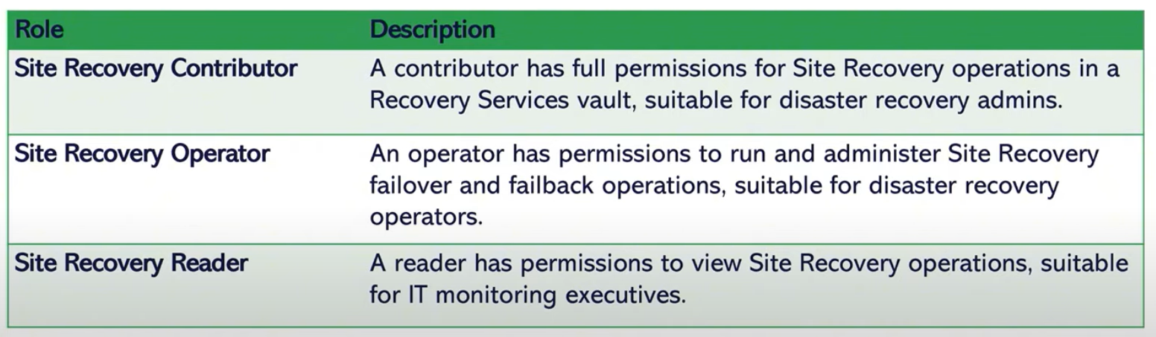

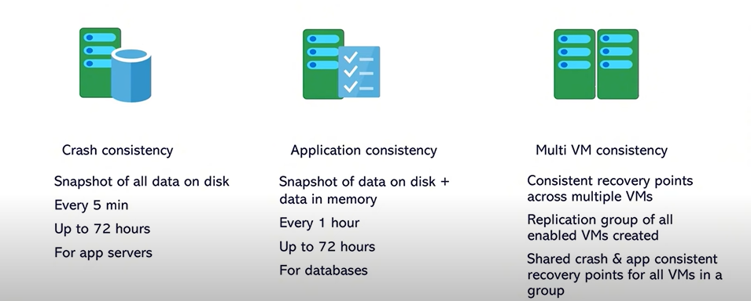

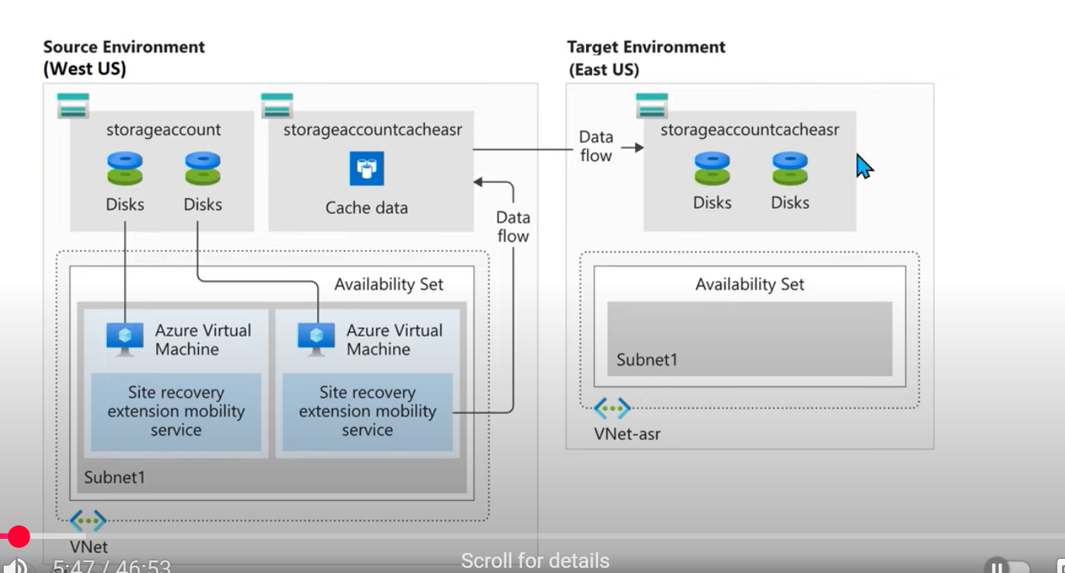

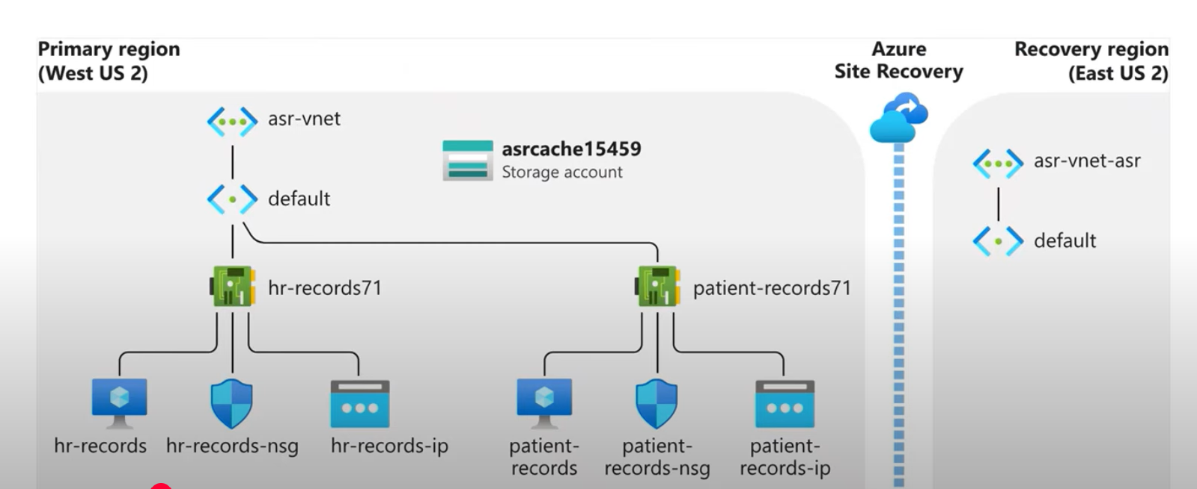

Crash Consistency

Captures data at a specific point in time, like a sudden power failure. No guarantee of database or application integrity.

Application Consistency

Ensures databases, applications, and in-memory transactions are correctly captured (via VSS for Windows & pre/post scripts for Linux).

Uses Volume Shadow Copy Service (VSS) for Windows and custom pre/post scripts for Linux to create proper snapshots

Azure Site Recovery allows organizations to define their Recovery Time Objective (RTO) and Recovery Point Objective (RPO):
Tier | Recovery Point Objective (RPO) | Recovery Time Objective (RTO) | Use Case
Tier 1 | Near Zero | Few Minutes | Mission-critical applications
Tier 2 | 15-30 minutes | 1-2 hours | Business-critical applications
Tier 3 | 1-2 hours | 4+ hours | Non-critical applications

Test Failover (TFO)

Validate DR setup without affecting production.

Commit
Confirms failover is complete, deletes old recovery points.

Re-Protect
failback
Enables replication back to original site or another region.

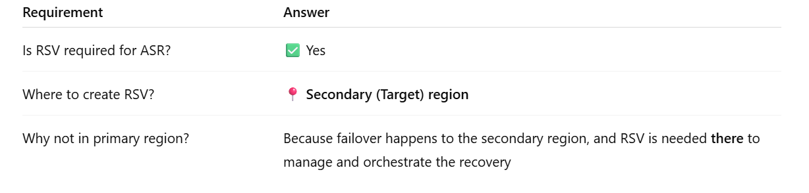

4. ✅ Failover
- Switches workloads from the primary site to the secondary (DR) site during:
  - Real disaster
  - Planned downtime (e.g., maintenance)
- VM boots up in the target region/location using the latest available data.
5. 🔁 Commit -Finalize failover and make DR site primary
- Confirms the failover was successful.
- Removes recovery points from source and makes the DR site primary.
⚠️ Cannot go back once committed.
6. ♻️ Re-Protect-Setup reverse replication post-failover
- Used after failover is committed.
- Starts reverse replication from new primary (DR) to original site to prepare for failback.
🧠 You can’t failback until re-protection is done.
7. 🔃 Failback-Restore services to original primary site
- Moves workloads back to the original primary site after it's restored.
- Steps:
  - Re-protect DR VM back to original site
  - Wait for sync
  - Perform Planned Failover
  - Commit

Test Failover | DR test without production impact

Recovery Plan | Automated failover sequence

Replication Policy | Defines replication frequency and retention

Recovery Point | Snapshot used during recovery

